Exercise 3
- List all employees whose last names begin with P.
Answer: SELECT * FROM employee_data WHERE l_name LIKE 'P%';

- Display the names of all employees in the marketing division.
Answer: SELECT f_name, l_name FROM employee_data WHERE title LIKE '%Marketing%';

- What will the following statement display: SELECT f_name, l_name, salary from employee_data where f_name like '%k%';
Answer:
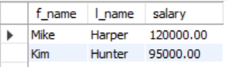

- List the last names and titles of all programmers.
Answer: SELECT l_name, title FROM employee_data WHERE title LIKE '%Programmer%';

